**COMMVAULT LIVE MIGRATION**

**Step 1.**

Go to schedule policy.Find the policy as per migration i.e 22E then right click and disable.

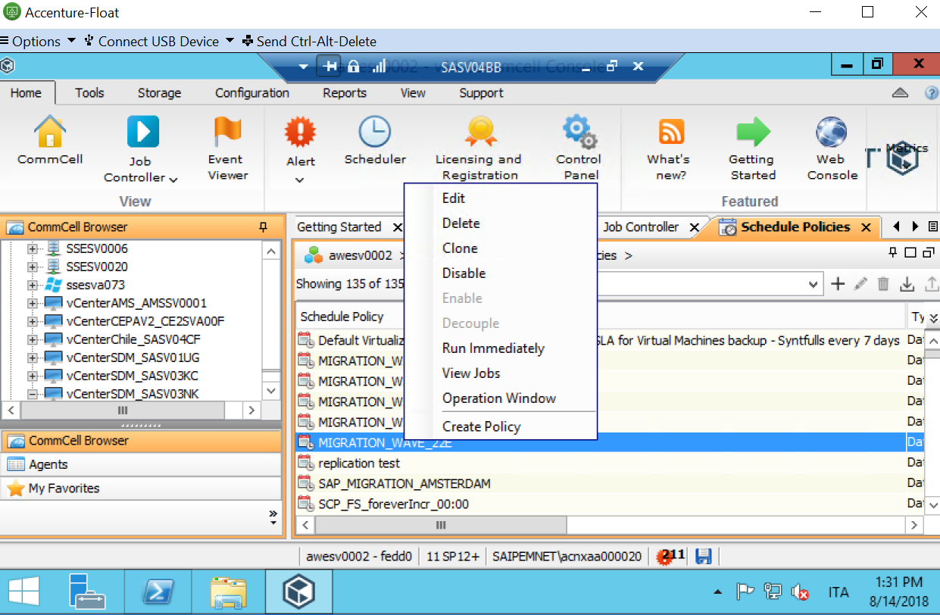

**Step 2.**

Goto commvalut console and server related vCenter.(Sasv03kc,Sasv03nk & Sasv01ug)

Click on default backupset and right click on server.

**Right click on server-🡪Lync sync-🡪Monitor**

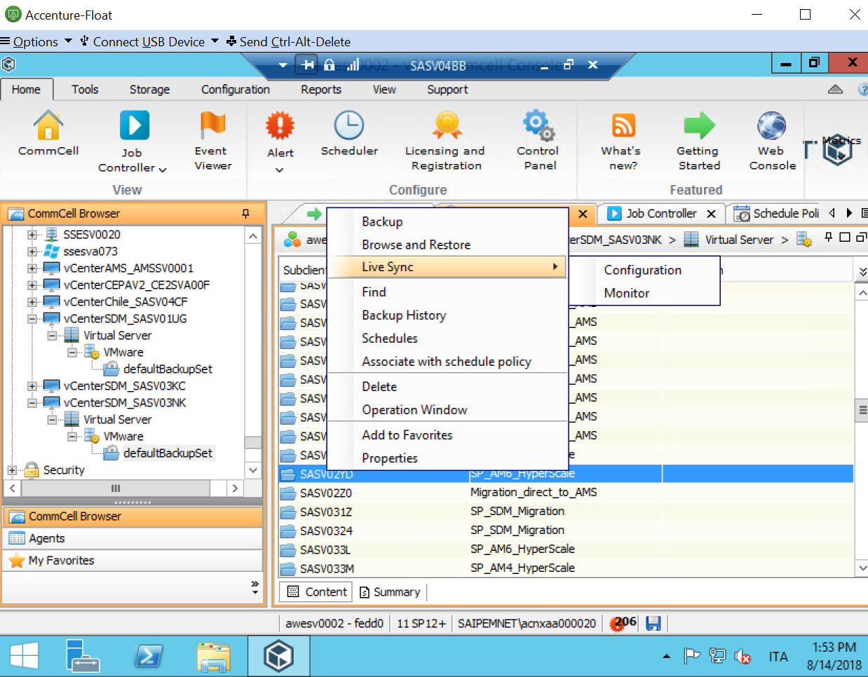

**Step 3**

Check server in sync and last backup status.

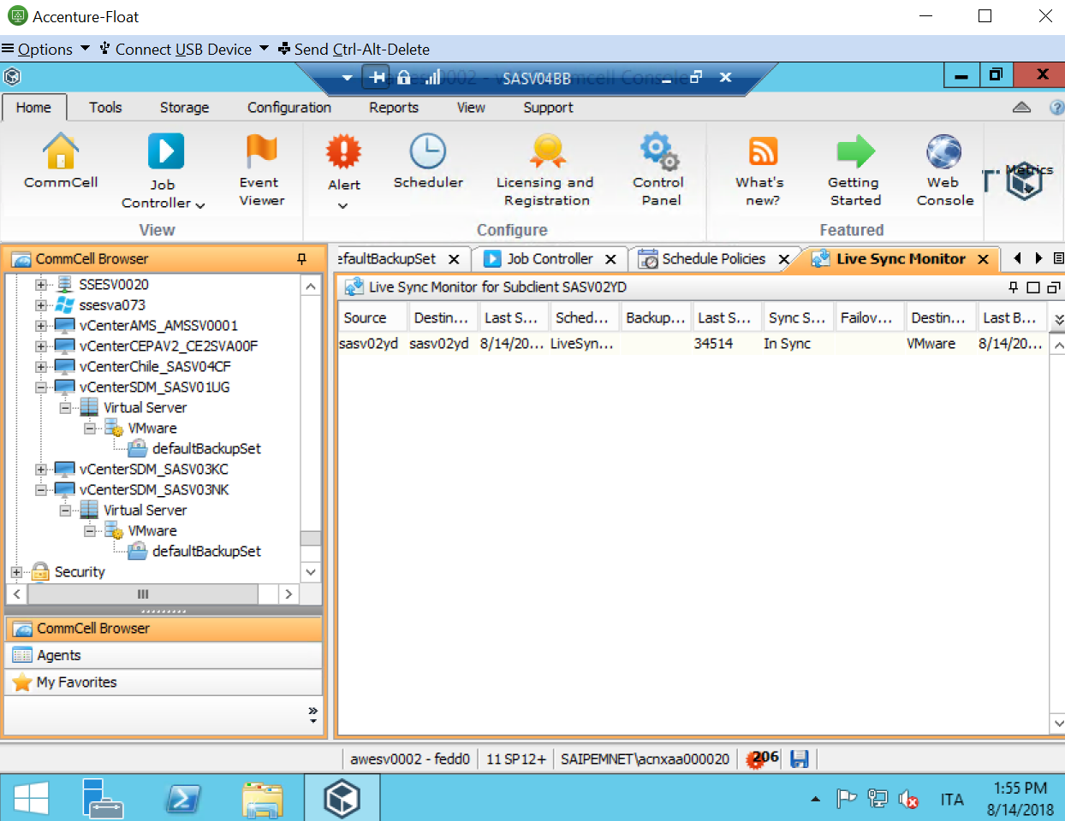

**Step 4.**

Right click on source server--🡪Failover---🡪Planned Failover-🡪 select server and click on OK

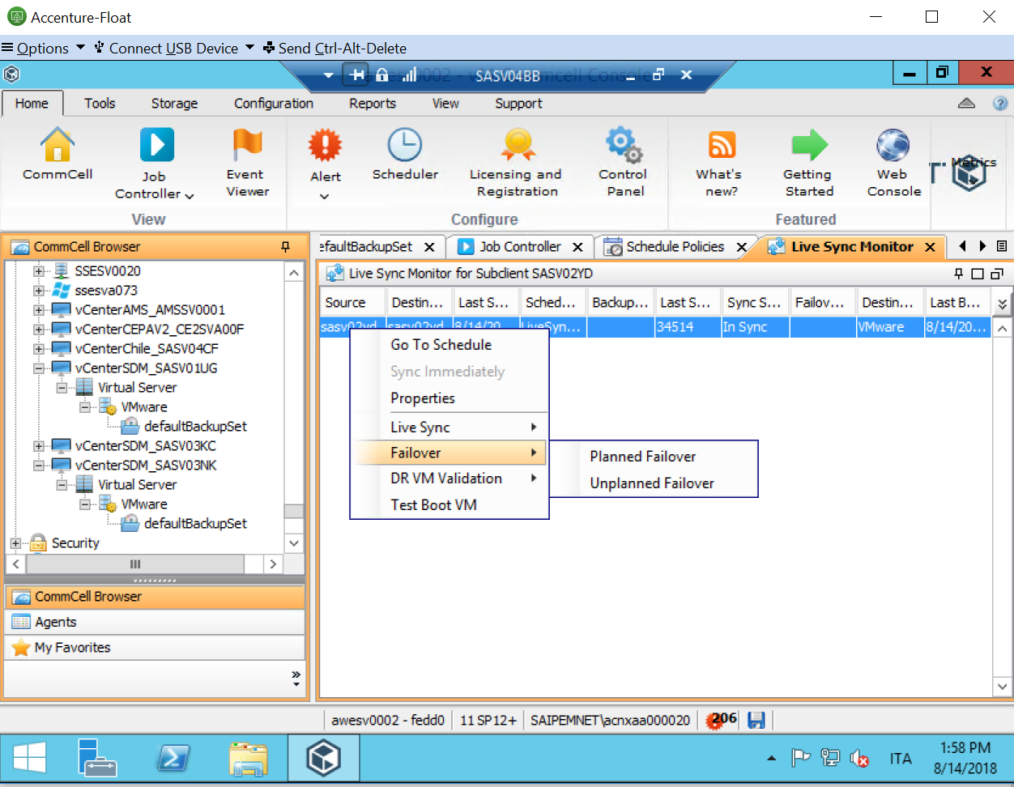

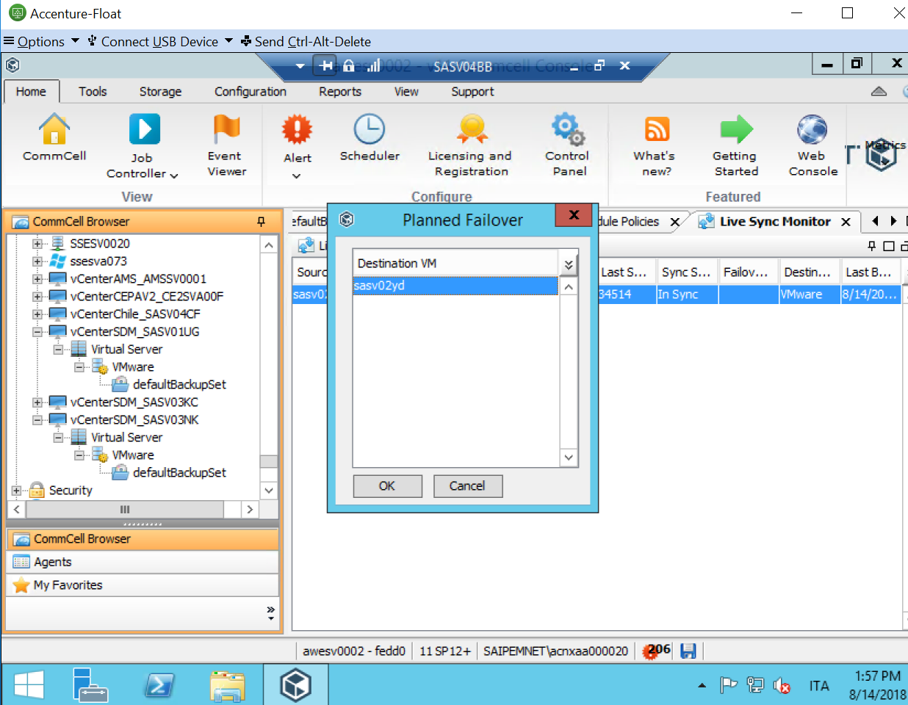

**Step 5.**

Goto Job controller. Note down Job ID and monitor

**Step 6.**

Once step no 5 is completed…Goto Target🡪server in “**POWER-ON” stage**

**Step 7**

Goto Source🡪server in “**POWER-OFF**” stage.

**POST MIGRATION**

**Step 1**

Goto source Vcenter-🡪search server-🡪Right click on server-🡪Rename(Migrated_Sasvxxx)

**Step 2**

**If windows server**

1. Change gateway
2. Install Macfee agent

**If Linux server**

1. Change gateway
2. NTP /NTPD